VISVESVARAYA TECHNOLOGICAL UNIVERSITY JANA SANGAMA, BELAGAVI - 560018



# A

**AICTE ACTIVITY POINTS REPORT ON**

# “Helping Local Schools To Achieve Good Result And Enhance Their Enrolment In Higher/Technical /Vocational Education ”

Submitted in partial fulfillment required for award of the Graduation Degree

**Bachelor of Engineering**

**In**

**INFORMATION SCIENCE AND ENGINEERING**

**By**

**ABHISHEK R 1HK20IS002**

Under the guidance of

|  |  |  |
| --- | --- | --- |
| **Prof. Ateeq Ahmed**  Assistant Professor  Dept. of ISE HKBKCE |  | **Prof. Shreelakshmi Yadav N**  Assistant Professor  Dept. of ISE HKBKCE |

**Department of Information Science and Engineering**

**2023 - 2024**

**HKBK COLLEGE OF ENGINEERING**

**22/1, Nagawara, Bengaluru 560045**

**E-mail:** [**info@hkbk.edu.in**](mailto:info@hkbk.edu.in)**, URL:** [**www.hkbk.edu.in**](http://www.hkbk.edu.in/)

# HKBK COLLEGE OF ENGINEERING

**DEPARTMENT OF INFORMATION SCIENCE AND ENGINEERING**

**PROGRAMME EDUCATIONAL OBJECTIVES (PEOs)**

* **PEO 1:** To Empower Students through Wholesome Education to achieve academic excellent education in the field of Information Science and Engineering**.**
* **PEO 2:** To Provide Students with in-depth disciplinary knowledge in engineering fundamentals that require to succeed in Information Science and Engineering**.**
* **PEO 3:** To Create Highly Qualified Professionals in multi-disciplinary areas with the knowledge of Information Technologies, Services Globally.
* **PEO 4:** To Inculcate in Students Professional and Ethical attitude with a strong character with effective communication skills, teamwork skills, multidisciplinary approach, and an ability to relate Engineering issues to broader social context**.**
* **PEO 5:** To Provide Students with an academic environment aware of advancedtechnological growth leading to life-long learning through innovation and research with professional ethics that uplifts mankind.

**PROGRAM SPECIFIC OUTCOMES(PSOs)**

**Professional Skills:**

An ability to identify and analyse requirements, and in designing and implementing well- tested technology solutions for rapidly changing computing problems and information system environments.

**Problem-Solving Skills:**

An ability to Design, develop and optimize solutions for information systems employing fundamentals of system hardware & software, graph theory, finite automata, data storageand communication networks.

**Collaborative Skills:**

An ability to communicate and develop leadership skills and work effectively in team environments. They are capable of collaborating to design and implement well tested solutions for rapidly changing computing problems and information system environments.

**Successful Career and Entrepreneurship Skills:**

An ability to adapt for innovation and changes and be successful in ethical professional careers along with the impact of computing on society, and platforms in creating innovative career paths to be an entrepreneur, and a zest for higher studies.



**BENGALURU – 560 045**

**DEPARTMENT OF INFORMATION SCIENCE AND ENGINEERING VISVESVARAYA TECHNOLOGICAL UNIVERSITY**

# AN

**AICTE ACTIVITY POINTS REPORT**

ON

# “ Helping Local Schools To Achieve Good Result And Enhance Their Enrolment In Higher/Technical /Vocational Education ”

Submitted in partial fulfillment required for award of the Graduation Degree

**Bachelor of Engineering**

**In**

**INFORMATION SCIENCE AND ENGINEERING**

**VIII SEMESTER 2023 - 2024**

SUBMITTED BY:

**ABHISHEK R 1HK20IS002**

# ACKNOWLEDGEMENT

I would like to place my regards and acknowledgement to all who helped in making this AICTE Activity possible. I thank all those whose guidance served as a beacon of light and crowned our efforts with success.

First of all, I would take this opportunity to express our gratefulness to **Mr. C.M. Ibrahim**, Chairman, **Mr. C.M. Faiz Mohammed**, Director and for all the facilities provided to complete the AICTE Activity in time.

I express my sincere gratitude to **Dr. Riyaz Ahmed**, Principal, HKBKCE for her support which inspired me towards the attainment of knowledge.

I wish to acknowledge the contributions of **Dr. A Syed Mustafa**, HOD, Information Science and Engineering for manifestations in great depths and helped me to complete the assigned task on time.

I sincerely thank my guide **Prof. Ateeq Ahemd and Prof. Shreelakshmi Yadav N** , Assistant Professor, and **Dr. Usman Aijaz. N**, Assistant Professor and AICTE Coordinator for their constant assistance, support, patience, endurance and constructive suggestions for the betterment of the AICTE Activity.

Finally, I thank Almighty, all teaching and non-teaching staff of the Department of Information Science and Engineering, my parents, family members and friends for their valuable guidance and cooperation throughout my dissertation.

**ABHISHEK R 1HK20IS002**

# ABSTRACT

The exercise was carried out to help enhance learning opportunities and to give new, aspiring engineers a chance to have an improved impact on society, allowing secondary school pupils to get knowledge from graduate students' experience. The school student enrolled in the integrated learning course that used cycle appraisal to assess student learning outcomes by combining various learning activities through a learning management framework. The quantitative results obtained after analyzing examination data from the system using a misuse backslide inquiry shown that the understudies who successfully engage in class activities have better outcomes. According to quantitative insightful data, understudy-understudy cooperation has a significant impact on understudy learning outcomes. These learning activities were used as proposals for discussions to organize and conduct out learning activities for integrated learning courses across the curriculum, as stated through contact.

# TABLE OF CONTENTS

## Chapter Title Page No

**ACKNOWLEGEMENT ABSTRACT**

Chapter1 INTRODUCTION 1-7

* 1. Vocational Education 1
  2. Introduction 2
  3. Class Room Management 4

Chapter 2 SIGNIFICANCE AND PURPOSE OF ACTIVITY 8

* 1. Why target Local Schools 8
  2. Significance of the Activity 9
  3. Purpose of the Activity 12

Chapter 3 PROJECT IMPLEMENTATION 15

* 1. Project Work in Practice 15
  2. The Project Pathway 16
     1. Introduction 16
     2. Choice Of Topics 19
     3. Planning 21
     4. Problem Formulation / Research Questions 22
     5. The Implementation Phase 24

Conclusion 25

Certificate 26

# CHAPTER - 1

**INTRODUCTION**

## VOCATIONAL EDUCATION

A programme of study called vocational education, commonly referred to as career and technical education (CTE), is designed to educate students for a particular profession or trade. It offers hands-on instruction and useful skills that are pertinent to particular occupations and industries. As more people became aware of the need for specialized skills and training that go beyond what is provided in conventional academic programs, this sort of education grew in popularity throughout time. Although the breadth and structure of vocational education programs vary greatly, they all aim to educate students for rewarding careers in a particular industry. High schools, community colleges, trade schools, and other educational institutions also provide these programs. They may also be made available as a part of an apprenticeship programme, which combines on-the-job training and classroom instructions.

Courses that are pertinent to the profession or trade selected are often included in the curriculum of vocational education programs. A nursing programme might contain classes in anatomy, pharmacology, and patient care, whereas a welding programme might include courses in welding safety, blueprint reading, and welding procedures. Vocational education programs frequently offer practical training in addition to academic instruction through internships, apprenticeships, and other work-based learning opportunities.

Vocational education trains people for in-demand jobs and industries, which is one of its key benefits. To guarantee that students are trained in the skills required in the workforce, many vocational education programs are developed in collaboration with local firms and industries. This implies that graduates of vocational education programs have a higher likelihood of landing a job in their sector of choice and may be able to demand higher compensation than non-graduates. Vocational education also has the benefit of taking less time to finish than standard academic programs. This is so because vocational education programs are centred on imparting the precise knowledge and skills required for a given occupation or trade. People who wish to enter the workforce fast and do not want to spend several years in a regular academic programme may find this to be particularly appealing.

There are numerous ways to receive a vocational education, including:

* + Programs that provide instruction and training in a variety of professions, including healthcare, construction, automotive technology, and culinary arts, are known as career and technical education (CTE) programs at high schools and community colleges.
  + Apprenticeships, which give those who wish to acquire a skilled trade—like plumbing, electrical work, or carpentry—on-the-job training and classroom education.
  + Trade schools that provide specialized instruction in industries like welding, cosmetology, or computer repair.
  + Community colleges and technical schools offer certificate and degree programs that offer training and education for a range of professions and industries, including nursing, accountancy, and web development.

Vocational education aims to equip students with the practical skills and information required to succeed in particular industries and occupations in order to prepare them for success in the workforce. Vocational education can assist students in developing the abilities and self- assurance they need to succeed in the labour market and create fulfilling professions by providing hands-on instruction and real-world experience. Overall, the educational landscape includes a significant and valuable role for vocational education. It helps close the skills gap that occurs in many businesses by giving people the information and abilities they need to excel in particular professions and industries. Vocational education will remain a crucial tool for people who wish to have successful and fulfilling professions as the work market changes and evolves.

## INTRODUCTION

Every everyone deserves the fundamental right to an education. It is the key to opening doors for both personal and professional development, and neighbourhood schools are crucial in giving pupils access to a top-notch education. However, many neighbourhood schools struggle to improve their enrolment in vocational education while also producing strong academic performance. This could be caused by a number of things, including a lack of funding, limited access to technology, poor student assistance, and a lack of community involvement. Local schools must create a comprehensive strategy that prioritizes offering individualized learning experiences, practical learning opportunities, academic assistance, and community participation to meet these issues. For instance, by working with nearby

companies, schools can offer students priceless work-based learning opportunities that aid in their understanding of various career choices and the development of crucial skills. By giving pupils the chance to apply what they learn in class to real-world settings, this can also improve the vocational education programs offered by the schools.

Furthermore, providing customized learning opportunities like project-based learning and individualized instruction helps keep students interested in and motivated to study. Sports, clubs, and other extracurricular activities can assist students in pursuing their interests and developing their talents outside of the classroom. Giving academic support to struggling students through tutoring, mentor ship, and other programs can help them stay on track and succeed in their studies.

For neighbourhood schools to be successful, it is also essential to involve parents and the community. Schools can raise awareness of the value of education and motivate parents to support their children's academic progress by hosting open houses, parent- teacher conferences, and other events. Schools can collaborate with community organizations to provide students with more chances and resources. Local schools may find it difficult to improve academic performance and to increase enrollment in vocational education, but by implementing a comprehensive strategy that incorporates individualized learning experiences, practical learning opportunities, academic support, and community engagement, schools can enhance educational outcomes and have a positive impact on their students and communities. The purpose of schoolwork is for students to grow and learn. We must also be ready to learn throughout our lives in order to succeed in modern society. Lifelong learning is a process. Knowledge is therefore a finite good, necessitating constant study and growth in order to stay up with societal advancements. As engaged citizens, we may use our knowledge to further the advancement of our society. As a result, after completing their official education, students should be encouraged to continue learning throughout their lives by using their innate curiosity and constantly asking questions about the world. There are various teaching strategies that tap into students' natural interest.

For the students' activities, exploratory work and problem-based learning may be used as a starting point. We arrive to the project-work technique while thinking about instruction that intends to pique students' interest and subsequently their commitment. This

method is started by developing an issue or a research question. According to research, even though there is a high degree of student involvement in class, struggling students might not find this inspiring ( Haug, 2012 ). Additionally, research demonstrates that there is little student cooperation and teacher-student interaction. According to Haug, current research suggests variety in work formats since varied learning tactics benefit students. He also adds that we shouldn't be content with employing the methods without further exploring their implementation.

The purpose of schoolwork is for students to grow and learn. We must also be ready to learn throughout our lives in order to succeed in modern society. Lifelong learning is a process. Knowledge is therefore a finite good, necessitating constant study and growth in order to stay up with societal advancements. As engaged citizens, we may use our knowledge to further the advancement of our society. As a result, after completing their official education, students should be encouraged to continue learning throughout their lives by using their innate curiosity and constantly asking questions about the world. There are various teaching strategies that tap into students' natural interest. The objective of teaching in Norway's lower secondary schools is to provide a diversified and practical curriculum that the students would find engaging and challenging (Indian Ministry of Education, 2021). The goal is to boost the students' motivation and academic performance. This exercise demonstrates how the project-work technique can make learning engaging, applicable, practical, and demanding. Examining the teacher's leadership of the students' learning in project activities is another goal of the activity. The activity report will conclude with a concise analysis of the potential benefits of project work for student motivation, growth, and learning.

## CLASSROOM MANAGEMENT

In vocational education, "classroom management" refers to the strategies and tactics teachers employ to establish a welcoming and stimulating learning environment that supports student learning and achievement. Because it can raise student achievement, lower disruptive behaviour, and boost student engagement, effective classroom management is essential in vocational education. The establishment of clear expectations and norms for behaviour is a crucial component of classroom management in vocational education. Teachers should make clear to students what is expected of them in terms of behaviour,

including how to interact with classmates and teachers, how to use tools and materials, and what is suitable conduct in the workplace. To ensure that students know what is expected of them, these expectations should be communicated to them in a clear and consistent manner. Providing students with experiential learning opportunities that are pertinent to their professional objectives is a crucial method for managing the classroom in vocational education. This can include assignments, internships, and other forms of experiential learning that let students use their knowledge and abilities in actual situations. Teachers can support students' continued engagement and motivation to learn by offering these kinds of experiences.

Teachers must also take the initiative to deal with disruptive behaviour in the classroom. The use of techniques like rewarding good behaviour, giving prompt feedback, and taking remedial action when required might be included in this. Since strong relationships with students can lessen disruptive behaviour and increase student engagement, teachers should attempt to cultivate these ties with their pupils. Utilizing technology and other resources to improve student learning is another aspect of effective classroom management in vocational education. This may involve using educational software, virtual reality simulations, and other tools to give students practical experience in the subject of their choice. In order to give students the skills and knowledge they need to succeed in the workforce, teachers should also be knowledgeable about the most recent technologies and trends in their industry.

In vocational education, effective classroom management is essential for fostering an environment that is supportive of students' success. Teachers can design a classroom that prepares students for success in their chosen careers by establishing clear expectations, offering practical learning opportunities, dealing with disruptive behaviour pro-actively, and utilizing technology and other resources.

Doyle (1986) noted that classroom management serves two functions. In order for students to engage in meaningful learning, the classroom must first be made tranquil. Second, effective classroom management must promote students' moral and social development. Doyle therefore defines classroom management as providing an atmosphere that can support students' academic and social growth. Teachers who create a welcoming

learning environment and preserve silence so that students may focus on their work are strong leaders, which makes them also good teachers. According to this understanding, the teacher serves as a leader by guiding the students towards their learning tasks and so making learning easier for each student (Ogden, 2004).

A positive learning environment and a community that values learning are what classroom management is all about, according to a social - constructionist viewpoint (Prawat, 1996). Doyle (2006) asserts that in order to do this, a classroom environment where the teacher fosters a calm learning environment and actively participates in the learning process is necessary. According to Friedman (2006), teachers may find it difficult to strike a balance between establishing order for learning and directing the students' learning activities. Teachers' roles as facilitators of students' learning activities are topics of interest to both the educational system and research.

According to research (Hattie, 2009; Nordenbo, Larsen, Tiftikci, Wendt, & stergaard, 2008), effective leadership is crucial for students' learning outcomes. For effective classroom management, it is necessary to comprehend the class as a social system. The students come from various social and cultural backgrounds. They each have unique mastery experiences and expectations for what education should be for them and how they can best contribute to their own learning and the learning community. When describing the classroom with six concepts, Doyle (2006) adopts an ecological viewpoint. It is multidimensional—many things happen on various levels—simultaneous—many things happen at the same time, immediate—events change quickly, unpredictable—events may take unexpected turns, public—many people are watching the events, and historical— classes frequently meet for a long time and develop shared norms, routines, and understandings that affect how the class moves forward. Working with a class requires interacting with the constituent components and their interpersonal relations.

Project work is well-described by Doyle's six notions (2006), which describe the classroom and the activities. The students typically use a variety of issue formulations and research topics, pursuing the solutions in diverse contexts both within and outside of the classroom. In order to deal with the unknown, the teacher must be able to lead processes where a lot happens rapidly and simultaneously as well as processes that are started by the

students. As the project's leader, the instructor is faced with the difficulty of developing a group knowledge of how to interact with one another and the academic work. The educator is thus faced with the difficulty of fostering a positive learning environment and assisting the students as they attempt to answer the research questions they have chosen. The necessity of fostering a healthy learning environment for students is emphasized from Arthur Doyle's perspective on classroom management. He points out that good classroom management serves two essential purposes. The first step is to create a calm setting where pupils can participate in worthwhile learning. In order for pupils to concentrate and focus on their work without interruptions or disturbances, the classroom needs to be a calm and serene environment.

Promote students' moral and social growth is, in Doyle's opinion, the second purpose of good classroom management. This entails fostering an environment in the classroom where kids feel safe and appreciated, one that is helpful and favourable to learning. Teachers can do this through cultivating strong relationships with their pupils, promoting teamwork and mutual respect, and serving as positive role models. Doyle believes that managing a classroom involves more than just upholding discipline and order. Instead, it focuses on developing a setting that can foster students' intellectual and interpersonal development. His definition of classroom management is creating an environment that can support learning and aid students in acquiring the skills they need to be successful in life.

Doyle asserts that teachers who foster a friendly learning environment and uphold silence so that pupils may concentrate on their work are effective leaders. They facilitate learning for each student by directing them towards their own learning activities. Teachers can assist students in acquiring the abilities necessary to become autonomous and self- directed learners by acting as leaders and mentors. Overall, Doyle emphasizes the value of fostering a supportive learning environment that fosters students' social and academic development in his perspective on classroom management. Teachers can aid in the development of their students' life skills by developing healthy connections, encouraging teamwork and mutual respect, and setting a good example of positive behaviour and attitudes.

# CHAPTER - 2

**SIGNIFICANCE AND PURPOSE OF THE ACTIVITY**

## WHY TARGET LOCAL SCHOOLS

Local schools are a primary focus for projects promoting vocational education for a number of reasons:

* + **Community Connections :** Community Relations Since local schools frequently have strong relationships to their neighborhoods, they are in a good position to offer chances for vocational education that are specifically catered to the demands of neighbourhood businesses and industries. Schools can make sure that their vocational education programs are giving students the skills they need to succeed in the local workforce by collaborating closely with local employers.
  + **Accessibility :** By focusing on neighbourhood schools, chances for vocational education are made more available to students who would not have the resources to travel to other parts of the city or state to attend programs in this field. This can ensure that all students have access to chances for high-quality vocational education.
  + **Economic development :** Local schools can support economic development in their areas by offering students opportunities for vocational education that are customized to the needs of regional businesses and industries. This may entail luring new companies, generating employment possibilities, and raising the earning capacity of locals.
  + **Community Engagement :** Local schools can interact with their communities and forge closer ties with nearby companies and industry titans by providing possibilities for vocational education. This may encourage participation and a sense of community pride, which may encourage future collaboration and collaborations.

**Proximity :** For students, particularly those who are unable to travel far to attend vocational schools or colleges , local schools are frequently the most convenient and accessible option. In rural locations where there may not be many transit options, this is particularly crucial.

* + **Customization :** Local schools have the option of tailoring their vocational education curriculum to the unique requirements of the regional labour market. Students may benefit from acquiring knowledge and skills that are current and in high demand in their community, which will improve their employment prospects.
  + **Economic development :** Offering options for vocational education that are in line with the demands of the local business community can aid in luring new companies and fostering local economic development. For students who complete vocational education programs, this may result in greater job options.
  + **Cost-effectiveness :** Local vocational education programs frequently outperform more expensive schools in terms of cost-effectiveness, opening them out to a wider spectrum of students. For low-income kids who might not be able to afford more expensive educational options, this is particularly crucial.

By focusing on local schools for vocational education programs, it may be possible to offer students convenient, individualized, and affordable educational possibilities that meet the demands of the regional labour market. May contribute to making ensuring that opportunities for vocational education are accessible to all students, are suited to the needs of neighbourhood businesses and industries, and can encourage local economic growth and civic involvement. Schools can support community growth and development while assisting in the workforce preparation of their students by making local investments in vocational education. A better local economy and more chances for students can result from this, which can help support economic growth.

## SIGNIFICANCE OF THE ACTIVITY

It is important for a number of reasons to assist local schools in achieving positive outcomes and increasing student enrollment in vocational education. First of all, it contributes to closing the skills gap that many businesses face. Employers are looking for workers with specialized skills and knowledge as sectors become more specialized and

technologically advanced. Local schools can assist in preparing students for the workforce and meeting the needs of regional businesses and industries by offering vocational education programs.

Second, alternative routes to success might be offered to kids through vocational education. Some pupils may struggle in typical academic environments since they are not all suited to them. Local schools can give students more relevant, hands-on training that is more engaging by delivering vocational education programs that are tailored to their interests and skills.

Thirdly, programs for vocational education can aid in enhancing the community's economic possibilities. Local schools can help to establish a pool of qualified workers that can draw firms and spur economic growth by training students for in-demand jobs and sectors. This may result in the creation of jobs, increased pay, and a more prosperous neighbourhood.

Fourthly, programs for vocational education can aid in closing the attainment gap that occurs in many educational institutions. pupils with impairments, pupils of colour, and those from low-income families have a lower success rate in conventional academic programs. Local schools may help level the playing field and provide all students an equal chance to achieve by providing vocational education programs that are tailored to match their requirements.

Last but not least, programs for vocational education can aid in preparing students for both job growth and lifetime learning. Numerous programs in vocational education give students the chance to obtain industry-recognized credentials and certifications, which can lead to new employment prospects and chances for progress. A person can adapt to shifting job markets and sectors by using the skills and information they acquire in vocational education programs in a number of contexts. Overall, there are many reasons why it is important to support local schools in getting good grades and increasing the number of students enrolled in vocational education. It can aid in closing the skills gap, offering different routes to success, enhancing the local community's economic prospects, closing the achievement gap, and preparing students for lifelong study and career advancement. Local schools can contribute to the development of a more qualified and prosperous

workforce that will benefit the entire community by making investments in vocational education. It is important in a number of ways to support local schools in getting good grades and increasing the number of students enrolled in vocational education. Some of the ways it can make a difference are as follows:

* + **Addressing the Skills Gap :**The abilities needed for many vocations are continually evolving in today's fast-paced, technologically advanced society. Finding employees with the requisite abilities to fill job openings is a challenge for many companies. Local schools can help close this skills gap by providing vocational education programs that prepare students for in-demand professions. By giving firms the qualified people they need, this can improve the local economy.
  + **Providing Diverse Routes to Success :** Not every student is a good fit for conventional academic programs. Local schools can give students more relevant, hands-on training that is more engaging by delivering vocational education programs that are tailored to their interests and skills. This may keep pupils interested in their studies and inspired to do well. Additionally, through apprenticeships, trade certificates, or other possibilities for vocational training, vocational education programs can give students additional paths to success.
  + **Enhancing Community Economic Prospects :** By preparing students for the jobs that are in demand in the area, local schools can contribute to the creation of a pool of skilled workers that can draw in employers and promote economic growth. This may result in the development of jobs, increased pay, and a more prosperous community.
  + **Reducing the achievement gap :** In traditional academic programs, children from low- income households, students of colour, and students with disabilities frequently have a lower chance of success. Local schools may help level the playing field and provide all students an equal chance to achieve by providing vocational education programs that are tailored to match their requirements.
  + **Preparing Students for Lifelong Learning and Career Advancement :** Several vocational education programs give students the chance to obtain industry-recognized qualifications and certifications , which can open up new professional pathways and

prospects for promotion. This helps to prepare students for lifelong learning and career advancement. A person can adapt to shifting job markets and sectors by using the skills and information they acquire in vocational education programs in a number of contexts.

It is important in many ways to assist neighbourhood schools in achieving positive outcomes and increasing their enrollment in vocational education. The achievement gap can be decreased, the skills gap can be addressed, alternative paths to success can be offered, the community's economic prospects can be improved, and students can be better prepared for lifelong study and professional advancement. Putting money into vocational education can benefit people, businesses, and the community as a whole.

## PURPOSE OF THE ACTIVITY

The goal of assisting neighbourhood schools in doing well and increasing their enrollment in vocational education is multifaceted and has the potential to significantly affect both the students and the neighbourhood.

First off, pupils will be more equipped to succeed in their chosen job pathways if they achieve strong academic grades. This is crucial since a strong foundation in fundamental academic disciplines like math, physics, and language arts is frequently required for vocational education. Students will be better able to handle the demanding requirements of vocational education and ultimately become more successful in their chosen industries by concentrating on improving academic performance.

Second, technical and vocational skills that are in great demand in the labour market can be taught to students through practical training in vocational education. Students can acquire the skills and information required to enter the workforce with confidence and competence by increasing their enrollment in vocational education. For the students individually as well as the community at large, this may result in better-paying jobs and increased economic prospects.

Thirdly, vocational education can offer a route for students to succeed in their academic and career goals even if they are not very interested in traditional academic areas. For students who might find it difficult to succeed in typical academic environments or

who have distinct learning styles, this is especially crucial. Local schools may contribute to ensuring that all students have the opportunity to realize their full potential by offering alternate routes to success.

Local schools can support economic development and job creation in the neighbourhood by collaborating with neighbourhood companies and business leaders. Schools can contribute to the development of a competent workforce that is better equipped to fulfil the demands of the local labour market by integrating their vocational education programs with the needs of local industry. Students who complete vocational education programs may have greater job prospects as a result of this, and it may also help the town draw in new enterprises and investment. In order to give students the academic and vocational skills they need to succeed in their careers, promote economic development and job growth in the community, and ensure that all students have the opportunity to reach their full potential, local organizations work with local schools to improve their performance and increase their enrollment in vocational education.

Giving pupils the information and skills they need to thrive in the 21st-century workforce is the goal of assisting local schools achieve strong results and increase their enrollment in vocational education. Some of the main goals of this effort are listed below:

* + High-Quality Education: This effort strives to give kids the knowledge and abilities they need to succeed in life by concentrating on enhancing the quality of education in neighbourhood schools. This may entail offering students a solid academic foundation in addition to real-world, hands-on training through vocational education programs.
  + Students' Workforce Readiness: The abilities needed for many vocations are changing at a rapid rate due to the high speed of technological change. Local schools can give students the skills they need to succeed in the workforce by increasing enrollment in vocational education programs. Training in fields like information technology, healthcare, and advanced manufacturing can fall under this category.
  + Addressing Skills Shortages: Many businesses are currently experiencing a skills deficit, which means they are having difficulty finding employees with the qualifications they

require to fill open positions. Local schools can assist alleviate these skill shortages by preparing students for in-demand jobs by increasing enrollment in vocational education programs.

* + Supporting Economic Development: Local schools may help with the local economy by giving students the skills they need to succeed in the workforce. This can entail luring in fresh companies, generating employment opportunities, and raising locals' earning potential.
  + Fostering Equity and Opportunity: Local schools may assist in levelling the playing field and fostering equity and opportunity for all students by giving kids access to high- quality educational and training options. Students from low-income households, students of colour, and students with disabilities, who may encounter additional success challenges, should pay particular attention to this.

The goal of providing students with the skills and information they need to thrive in the 21st-century workforce is to assist local schools in achieving strong results and increasing their enrollment in vocational education. This can involve offering top-notch instruction, putting students on the path to a career, solving the skills gap, promoting economic development, and creating equity and opportunity. Local schools may guarantee that their pupils are well-prepared for the future and have access to the chances they need to achieve by supporting vocational education and helping to ensure that it is funded.

# CHAPTER - 3

**PROJECT IMPLEMENTATION**

## PROJECT WORK IN PRACTICE

Dewey defined interest as a person's emotional attachment to a circumstance or setting that enables them to engage with and learn from their surroundings. This emotional connection to the environment encourages involvement and investment in the learning process, which improves memory and comprehension of newly learned material.

According to Dewey, learning entails continually rebuilding and reorganizing experiences in order to produce new knowledge and understanding. This implies that people of all ages can pick up new information, even if it is not necessarily fresh to others. According to Dewey, the term "interest" denotes a situation in which a person and their environment are interacting in order to promote development. This expression of a commitment on a personal, emotional level. Learning is the process of taking something from experience and applying it to one's future interactions with challenges. When young and old find something that is new to them, learning, which is a constant restructuring and reconstruction of experiences, occurs. This indicates that others may not be aware of the knowledge that is construed. The presentation of the activity that was completed in secondary school is shown below, utilizing the five phases as the presentation's structure.

Let's examine how the five phases can be used to present an activity that was completed in a secondary school environment.

* + **Preparation :** Planning and preparation for the activity are part of this phase. It might involve determining the learning objectives, acquiring the relevant resources, and choosing the most effective delivery techniques for the information.
  + **Introduction :** The exercise is introduced to the kids during this stage. This can entail outlining the lesson's goals, setting the activity's context, and inspiring enthusiasm among the pupils.
  + **Development :** This stage of the activity is where the majority of the learning takes place for the students. This may entail interactive exercises, group projects, or other active learning techniques that let students engage with the subject matter and one another.
  + **Conclusion :** In this stage, the exercise is over, and the pupils consider what they have learn. It might also entail asking students to share their experiences and ideas and assessing how well the activity's learning objectives were met.
  + **Follow up :** Following up with students after the activity to reinforce what they learned and offer further support if necessary is the last step in the process. This could entail setting up more meetings to discuss any unanswered questions, giving homework assignments, or providing extra resources.

It is possible to ensure that students are fully engaged in the learning process and that learning objectives are meaningfully addressed by using the five phases as a framework for presenting an activity.

## THE PROJECT PATHWAY

This includes the five phases that has been implemented in this activity with the captures of the activity done and interaction with the students, the detailed stages of implementation are given below.

* + 1. **INTRODUCTION**

The introductory stage is crucial since it establishes the overall project's tone. The participants' interest, motivation, and enthusiasm are its primary goals. To guarantee that the participants are involved and dedicated to the project throughout its duration, this is crucial. Important details like the project's goals, scope, and working technique are also provided at the introduction phase.

The project pathway's external frameworks are also chosen during this step. For the project to be successful, these frameworks comprise the rules, tools, and restrictions. The project's budget, schedule, supplies, and equipment, for instance, are all decided upon during this stage. These frameworks aid in ensuring the project's successful completion.

The first stage of the project can start once the introduction phase is finished. The choice of topics and the grouping of participants are typically involved in this. The project's goals and the participants' interests are taken into consideration when selecting a topic. Making sure that each group is made up of people with complementary knowledge and skills is another reason why it's crucial to divide the participants into groups.

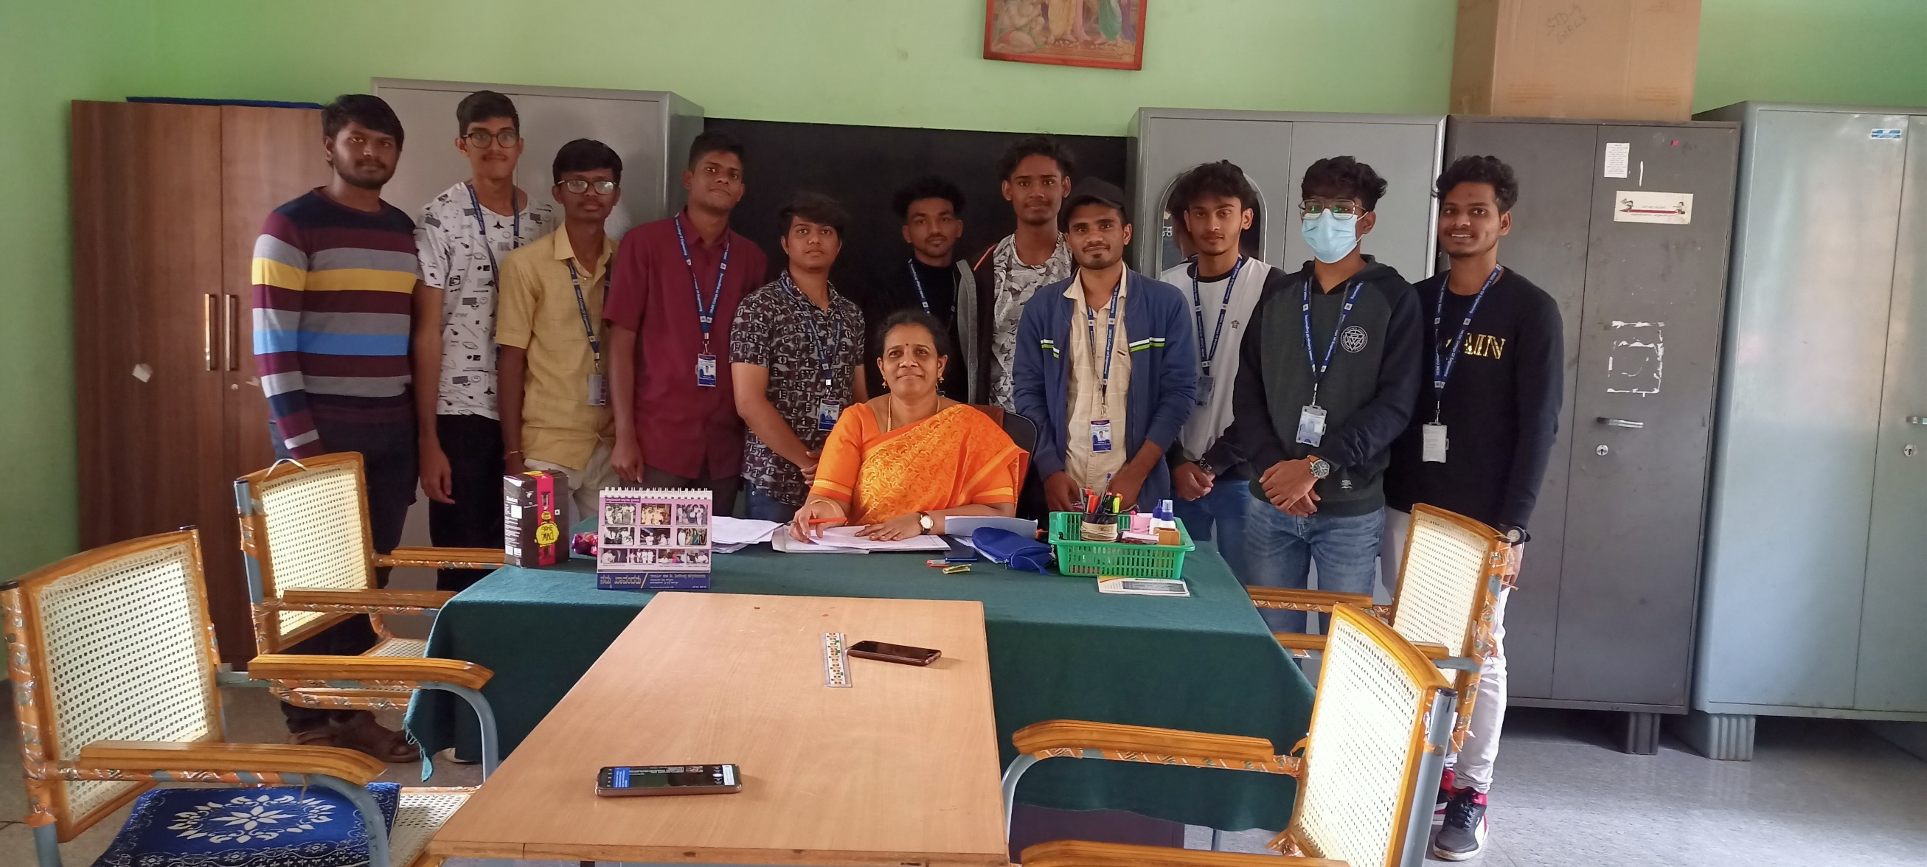

Fig 3.2.1 ( i ) The Head Mistress of School

The introduction is the first stage of the activity. This phase tries to motivate participants and educate them on the project work methodology itself. The project pathway's external frameworks are also chosen during this phase (Berthelsen et al., 1987). The first phase of the project, which involves selecting themes and grouping the students, follows a motivational or introductory phase that was released prior to the start of the activity. Additionally, during this phase, the external frameworks for the project pathway are established, aiding in the efficient and effective completion of the project. The subsequent steps, such as topic selection and participant grouping, can start after the introduction phase is finished.

Fig 3.2.1 ( ii ) Division of students into group

* + 1. ( iii ) Interactions with students
    2. **CHOICE OF TOPICS**

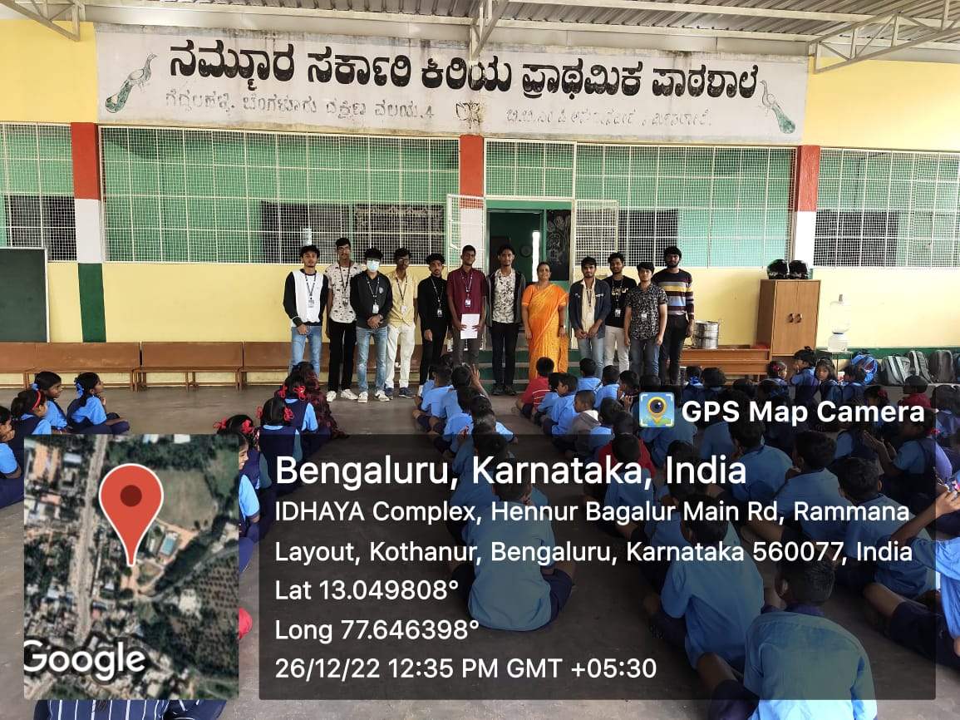

* + 1. ( i ) Interactions with students

A group of five people wanted to collaborate on a topic in the scenario you outlined, but there were only two ideas available. The two individuals who didn't have a topic were invited to a meeting by the project directors, and they were told to join already- existing groups. Both participants joined groups of four, with one joining a trio and the other a quartet.

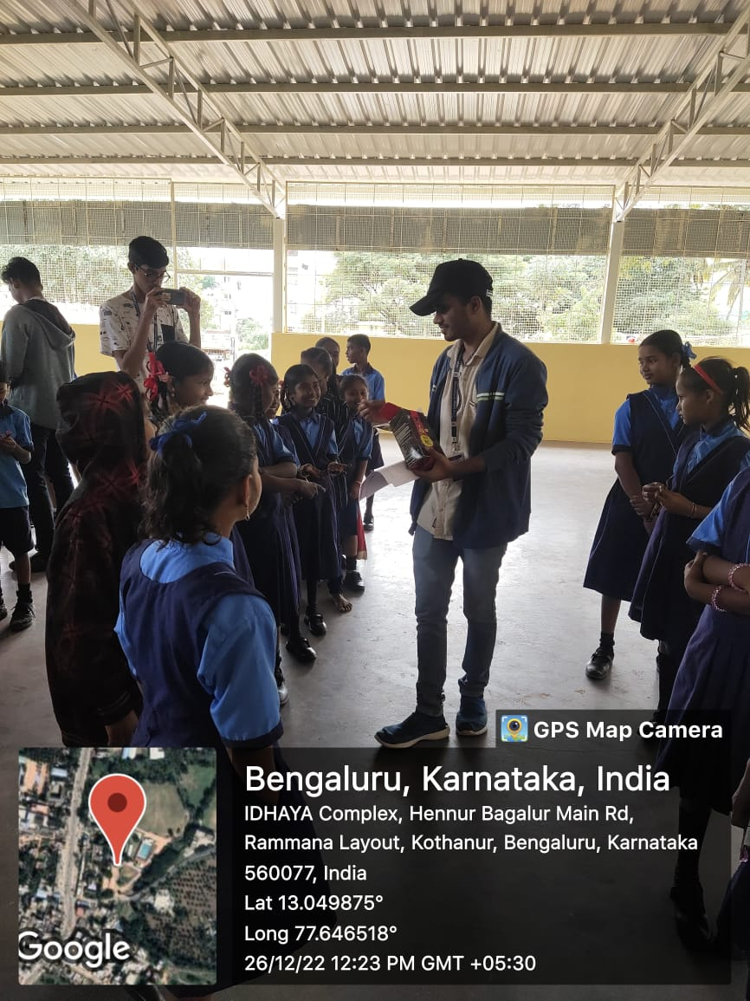

Fig 3.2.2 ( ii ) Working on the topic which of their choices

Grouping people can be difficult because it takes carefully taking into account each person's talents and interests. To guarantee that each group has the tools and expertise needed to finish the project successfully, though, is crucial. Additionally, it may encourage cooperation and teamwork among the participants.

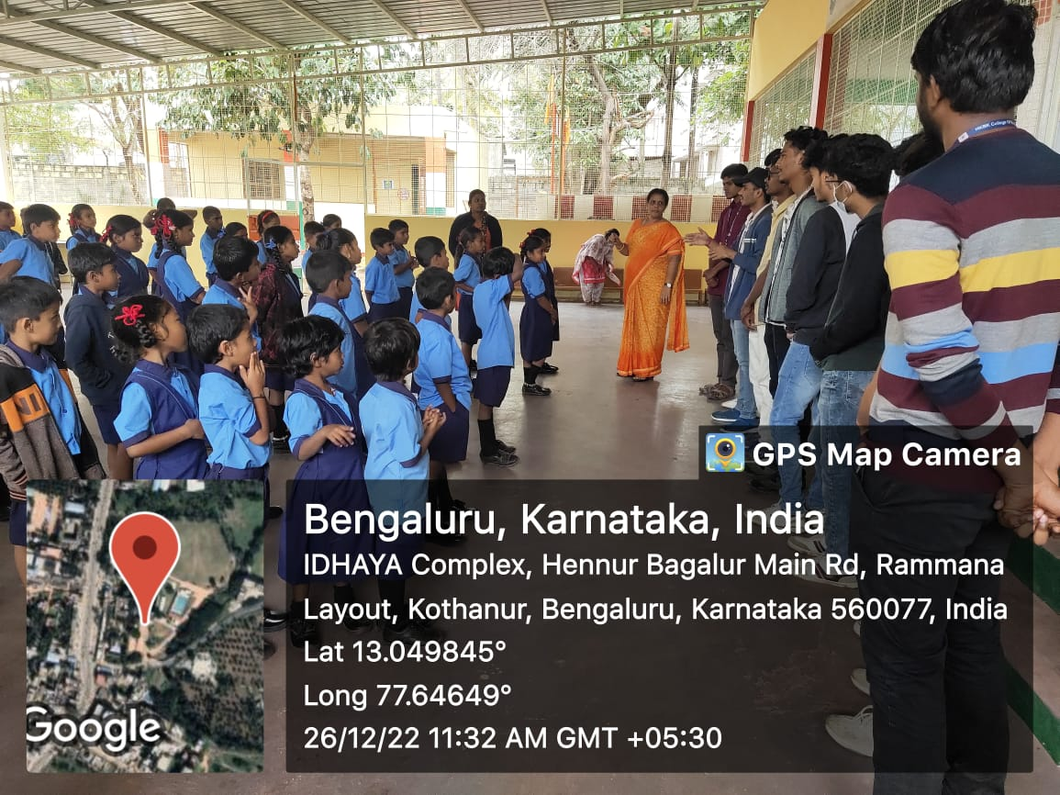

Fig 3.2.2 ( iii ) Interaction with students and Explaining about value of Education

A project's success depends on how topics are chosen and participants are organized into groups. It aids in ensuring that each group has the tools and expertise required to finish the project successfully. Although this procedure can be difficult, encouraging cooperation and teamwork among the participants is crucial.

* + 1. **PLANNING**

The project's execution process includes a vital phase of practical planning. It entails the project groups cooperating to schedule, distribute, and organize their work, as well as to choose literature sources and technology support.

Practical planning must include scheduling since it enables project teams to efficiently manage their time. The project leaders often give the participants a timeline to organize their work and make sure they have a general understanding of the available working hours. This can aid the participants in setting priorities for their job and managing their time well, which will boost productivity.

Another important component of practical planning is the allocation and organization of the work. Each participant's talents and shortcomings must be taken into account as the project groups divide up the work. This can ensure that each person is given duties that are suitable for their abilities, which can help the project succeed.

During the practical planning stage, the choice of literature sources and technology aids is equally crucial. The project groups must choose the books and technical tools they will utilize as resources for their work. Books, articles, internet resources, and software tools can all fall under this category. The effectiveness of the project can be greatly influenced by the selection of the literature sources and technical assistance because it can affect the calibre and accuracy of the projects output.

Each participant normally receives a project folder from the project leaders. Throughout the project, the papers of the participants are kept in this folder. By making sure that the work of the participants is well-organized and accessible, this can encourage collaboration and boost output.

A project's implementation includes a crucial period of practical planning. The project groups must coordinate their efforts to schedule, distribute, and organize their work, as well as to select literary sources and technical support. The success of the project may be influenced by the usage of a project folder and timeline to manage and organize the work of the participants.

* + 1. **PROBLEM FORMULATION / RESEARCH QUESTION**

A crucial phase in the project's execution is the problem defining phase. Each project group formulates and concertizes their problem at this phase by creating one or more problem formulations or research questions. This can assist the participants in narrowing their focus and ensuring that they are addressing the key problems associated with their topic of choice.

The project groups normally propose their research questions to the class after they have finalized them. The research questions for the various themes are posted on the board by a student from each group, which can help to ensure that everyone is aware of them and can offer criticism or recommendations for improvement.

An evaluation form for the activity presentation is presented before the students resume their group work. The teacher will use this form's several checkpoints to evaluate the presentation. The first checkpoint concerns the presentation's content and how well the groups have responded to their inquiry. This can ensure that the participants are concentrated on the key issues surrounding their topic and are giving the class precise, succinct information.

An evaluation form for the activity presentation is presented before the students resume their group work. The teacher will use this form's several checkpoints to evaluate the presentation. The first checkpoint concerns the presentation's content and how well the groups have responded to their inquiry. This can ensure that the participants are concentrated on the key issues surrounding their topic and are giving the class precise, succinct information.

It evaluates how words, particularly those in English, are pronounced. Verbal communication, or whether everything is articulated clearly and at an appropriate volume, is crucial. This can ensure that the speakers are clear in their communication and that their message conveyed clearly to the audience.

A checkpoint on the evaluation form pertains to the use of technical aids such projectors, the chalkboard, CDs, videos, television, and so forth. This can make sure that the speakers are using the right technological tools to assist their presentation and that they are effectively using those tools to get their point across.

An important stage in the execution of a project is the problem defining phase. Each project group is responsible for defining and enacting their specific challenge by

putting together one or more problem formulations or research questions. Checkpoints for presenting content, verbal communication, and the use of technical aids are frequently included on the assessment form used to rate how well the activity was presented. This can make sure that everyone is speaking clearly to the audience and that they are communicating successfully.

* + 1. **THE IMPLEMENTATION PHASE**

The organizations are now actively working to carry out their strategies and accomplish their objectives. This can entail compiling and evaluating data, working with team members, and making adjustments as required to guarantee advancement.

Meetings and conversations about mentor ship can be quite beneficial during this process. During these meetings, group members have the chance to express their ideas, worries, and concerns to one another as well as to their mentor, who will also offer advice and support.

The groups try to carry out the plans and objectives they have established during this phase, and they also try to answer the questions they have selected by gathering and analysing material (Berthelsen et al., 1987). During the course of the activity work, mentoring sessions and mentoring discussions with the students were conducted. Even though there were no issues during the work process, a number of issues were brought up during the discussion.

This stage's mission is to make sure the team stays on course and keeps moving closer to its goals. The team can overcome whatever challenges they face and attain the achievement they are aiming for by staying proactive and focused.

Even if the group is making good progress and running into few obstacles, several problems can still develop at this stage. Members could disagree on how to tackle a particular activity, for instance, or they might be having trouble managing their time or dealing with other practical issues. The group may work together to identify solutions and carry on moving forward by talking about these problems in a mentor ship discussion in an open and honest manner.

# CONCLUSION

It is crucial to assist local schools in achieving success and increasing student enrollment in higher/technical/vocational education because this can have significant positive effects on both people and communities. We can assist students in realizing their full potential and achieving their objectives by giving them access to high-quality education and the tools they need to succeed. Nevertheless, supporting neighbourhood schools can also have broader economic and social advantages. By giving students the knowledge and abilities they need to thrive in the workforce, we can contribute to boosting local economies and fostering stronger local communities. In order to accomplish these results, it is crucial to adopt a proactive and collaborative strategy, working closely with community leaders, educators, and schools to identify problem areas and create workable solutions. This can entail doing anything from funding teacher education and professional development to giving kids access to state-of-the-art tools and resources. We may ultimately contribute to the development of a better, more prosperous future for people, communities, and society at large by cooperating to support neighbourhood schools and improve educational opportunities for all students.

